**Creating File System:**

* First, we need to create a security group with default rules in VPC.

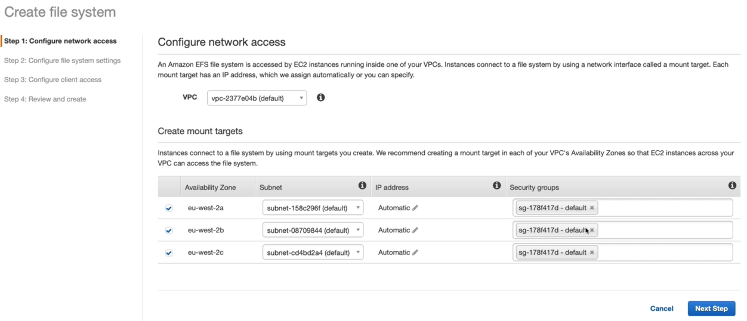

* Now, create an EFS file system in a VPC by selecting the availability zones, subnets and security group which we created.
* We can give one IP from subnet or we can leave it as automatic so that it will take a free IP automatically from the subnet

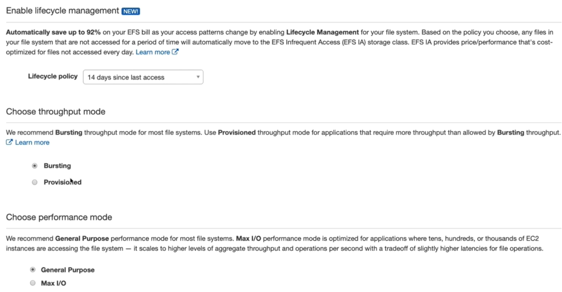

* In next step, we need give the tags and enabled lifecycle management.
* As above, if EFS is not getting accessed for 14 days then it will be moved to EFS infrequent access (AI).
* We can also give the performance mode as above.

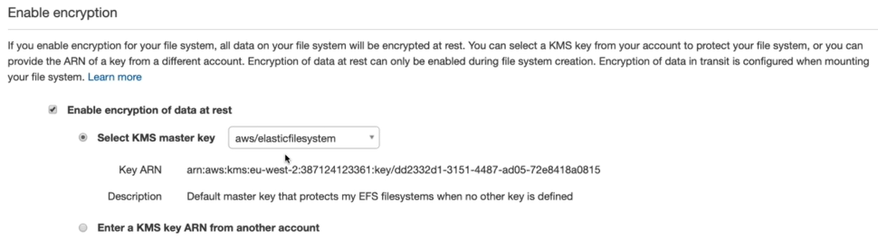

* We can also enable the file system encryption using KMS if we want.

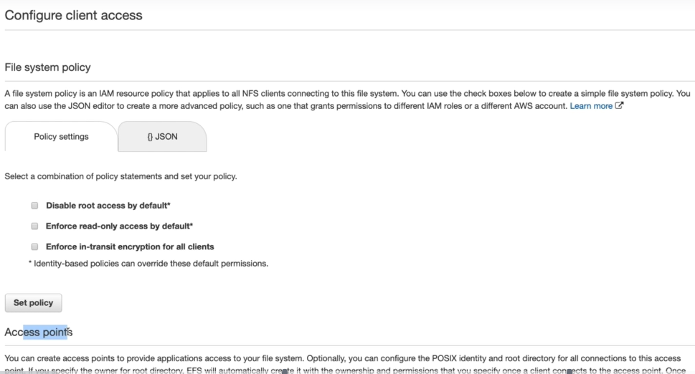

* We can enable client access and access points in next step as above.
* Then finally, we can review it and create.

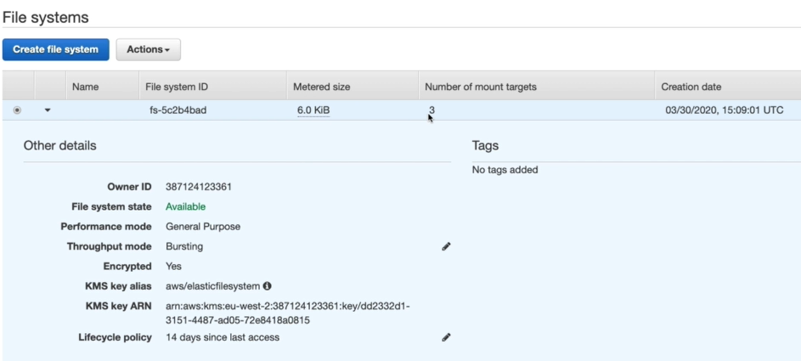

* Once created, we can see the file system ID and metered size above. Currently it is 6 KB. It will be increase once we start adding data to it.
* And we will be charged based on the size we use.

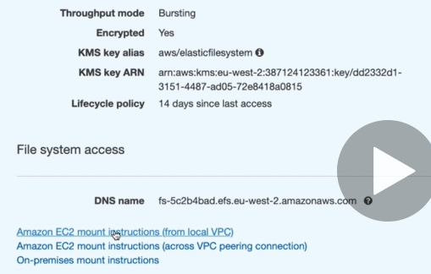

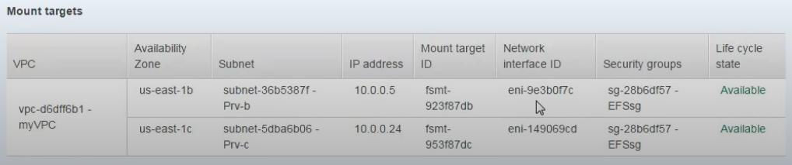

* We can also see that it takes one IP automatically as above.
* Now, we need to set the file system access. We can go for the first option.

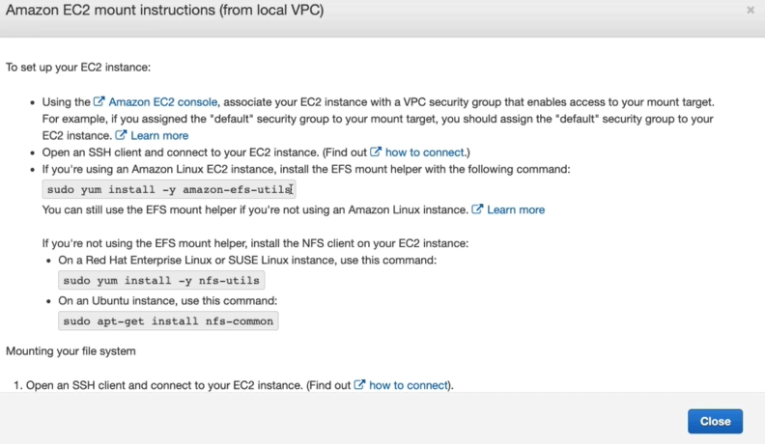

* We need to install EFS mount helper on the server with the given command above.
* We also need internet access on the server to install the efs utility. So make sure we have internet gateway attached to the server.

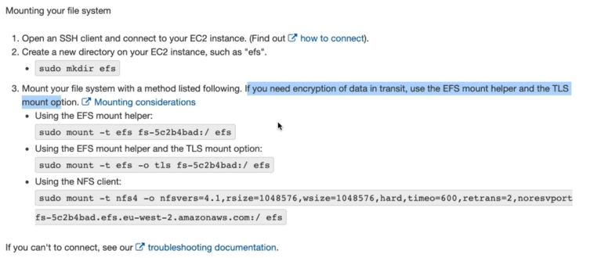

* We can mount EFS on the server with the above commands by creating efs directory.
* These commands might not work because we didn’t set any rules in security groups.

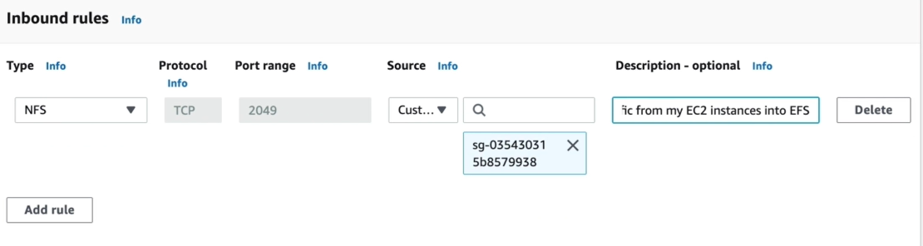

* We need to create inbound rules as above with NFS type because it is a network file system runs on 2049 port and need to give the source as security group of EC2 instances.
* Wherever you want to mount the file system, we need to add those security groups here to route the connection.

**Now, if we mount the driver on two instances suppose server1 and 2. Then both the servers will share the data between.**

**If we create a file in efs mount path of server1. Then the same will be reflected in server 2 as well.**